Simulation of FDMA in MATHLAB date
Objective 1
clc;
clear;
close all;

% User and Slot Configuration
Users = 1:8; % Total number of users
TotalSlots = 5; % Available TDMA slots

% Initialize slot allocation
Alloc = zeros(1, length(Users));

% Allocate slots to the first users
Alloc(1:TotalSlots) = 1;

% Identify blocked users
Blocked = 1 - Alloc;

% Display User-wise Slot Allocation
disp('User Wise Slot Allocation');

AllocationTable = table(Users', Alloc', ...
'VariableNames', {'User', 'Status'});

disp(AllocationTable);

% Create Figure
figure;

% Graph 1: Allocation per User
subplot(2,1,1);

stem(Users, Alloc, 'filled', 'LineWidth', 2);

title('TDMA Slot Allocation per User');
xlabel('User Index');
ylabel('Slot Status (1 = Allocated, 0 = Blocked)');

ylim([-0.2 1.2]);
xticks(Users);
grid on;

% Graph 2: System View
subplot(2,1,2);

plot(Users, Alloc, '-o', 'LineWidth', 2);
hold on;

plot(Users, Blocked, '-s', 'LineWidth', 2);

title('TDMA Slot Utilization Analysis');
xlabel('User Index');
ylabel('Status');

ylim([-0.2 1.2]);
xticks(Users);

legend('Allocated', 'Blocked', 'Location', 'best');
grid on;

hold off;
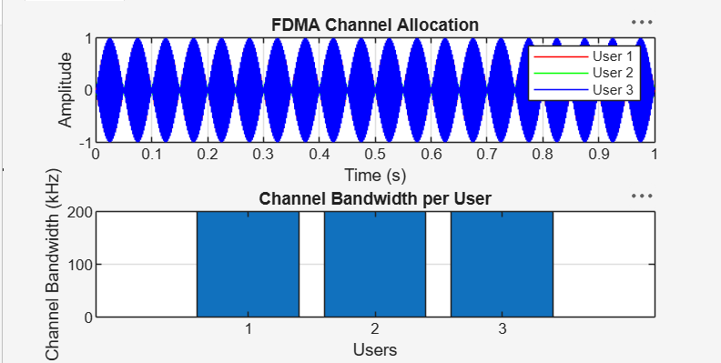

Objective 2
clc;
clear;
close all;

BW = 200; % Total Channel Bandwidth (kHz)
Users = 3; % Number of Users
M = 2; % BPSK Modulation

% Bandwidth allocated to each user
UserBW = BW / Users;

% Data rate for each user
DataRate = UserBW * log2(M);

% Data rate for all users
Rate = DataRate * ones(1, Users);

% Display results
disp('FDMA User Data Rate (kbps)');
disp([(1:Users)' Rate']);

% Plot bar graph
figure;
bar(1:Users, Rate);

xlabel('Users');
ylabel('Data Rate (kbps)');
title('FDMA Data Rate for Each User');
grid on;
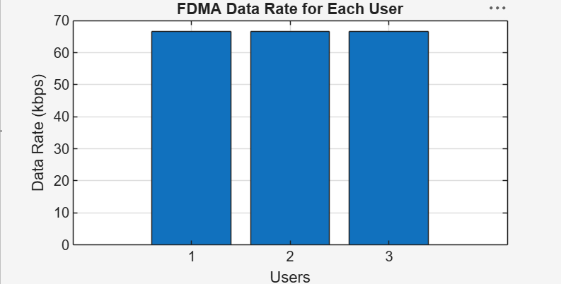

Objective 3
clc;
clear;
close all;

Ps = 1; % Signal Power (W)
Pn = [0.1 0.05 0.01]; % Noise Power for each user (W)
Users = 1:3; % Number of Users

% Calculate SNR in dB
SNR = 10 * log10(Ps ./ Pn);

% Display results
disp('User Noise Power (W) SNR (dB)');
disp([Users' Pn' SNR']);

% Plot SNR
figure;
bar(Users, SNR);

xlabel('Users');
ylabel('SNR (dB)');
title('Signal-to-Noise Ratio of FDMA Users');

grid on;

